**Project: Doctor Appointment System**

**Group Member:**

* InshaHabib (073)
* Musaffa Noor (089)

**Use Case Diagram:**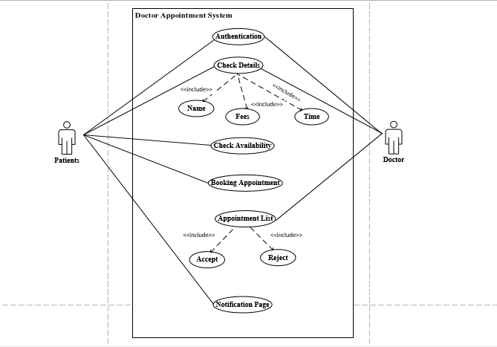

**Class Diagram:**